241024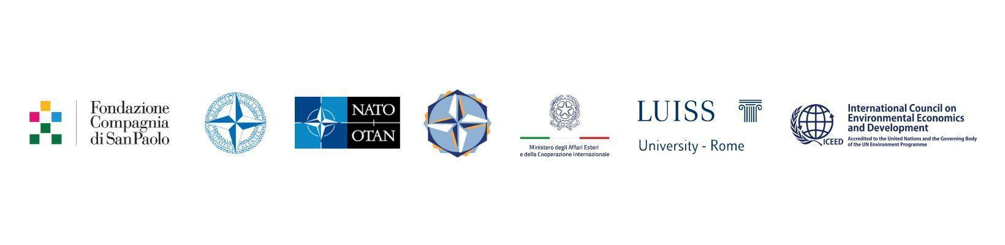

**ARAB GEOPOLITICS 2024 *Augmenting NATO Southern partnerships***

*High-Level Conference*

*Organised by the* ***NATO Defense College Foundation***

*with the support of* ***Luiss University***

*In co-operation with the*

***NATO Public Diplomacy Division,*** *the* ***NATO Defense College, Ministero degli Affari Esteri e della Cooperazione Internazionale,******Fondazione Compagnia di San Paolo*** *and* ***International Council on Environmental Economics and Development (ICEED)***

**Rome**, **25th of October 2024**

Venue: *Luiss University - Aula Toti*

*(Viale Romania, 32)*

***Friday, 25th of October***

**14,00 – 14,30** Participants Registration

**14,30 – 14,50** WELCOME REMARKS

* **Alessandro Minuto-Rizzo**, President, NATO Defense College Foundation, Rome *
* **Florence Gaub**,Director, Research Division, NATO Defense College, Rome *
* **Nicolò Russo Perez**, Head, International Affairs, Compagnia di San Paolo, Turin **

**14,50 – 15,05** OPENING REMARKS

**Giovanni Romani,** Head, Middle East and North Africa Section, Political Affairs and Security Policy Division, NATO HQ, Brussels **

**15,05 – 16,15**

*The Washington Summit has, after a long neglect, started to refocus on the Southern Region, following also the reflection by the Group of Experts, with some concrete initiatives like the liaison office in Amman, an appointment and future deadlines. Nevertheless, more is needed. The South should not be perceived as a heterogeneous entity for which it is difficult to find solutions and resources. How to change this narrative? How to structure a different discourse that allows to handle the region differently, in a more positive way? The Gulf Cooperation Council may be a good example of regional cooperation.*

Chair: **Matthew Robinson**,Director, Euro-Gulf Information Center, Rome *

* **Christian Koch**, Director, Research Division, Gulf Research Center, Brussels *
* **Ahmad Masa’deh**,Former Secretary General, the Union for the Mediterranean, Amman *
* **Luigi Narbone**​, **​**Director, Mediterranean Platform at the School of Government, Luiss University, Rome *
* **Len Ishmael**, Senior Fellow, Policy Center for the New South, Rabat *

*Q&A Session*

**16,15 – 16,45** *Coffee/Tea Break*

**16,45 – 17,55**



*The aim is to develop a converging strategic framework between NATO, the Mediterranean Dialogue partners and the Gulf Cooperation Council countries. What kind of policies can be implemented to foster an enhanced political dialogue and a practical cooperation? In fact, despite the diversity of the countries included, there are common security interests in various areas: security guarantees through prevention and resolution of crises; protection of essential maritime routes and infrastructures, alongside the security of energy supply and other essentials; blended risks like illicit trafficking, terrorism and hybrid operations.*

Chair: **Silvia Colombo**, Senior Researcher and Faculty Advisor, NATO Defense College, Rome *

* **Mahmoud Karem**,Professor, British University; former Ambassador to NATO and the EU, and Commissioner, Human Rights Council, Cairo *
* **Ebtesam Al-Ketbi**,President and Founder, Emirates Policy Center, Abu Dhabi *
* **Manal Al Hasawi**, Founding Partner, Think Tank Strategy & Development Consulting, Kuwait City *

*Q&A Session*

**17,55 – 18,05** *Special Intervention*

**Benedetto Della Vedova**, Member of Parliament, Foreign Affairs Committee, House of Deputies, Rome

**18,05 – 18,15** *Special Intervention*

**Aaron Leshno-Yar**, Former Ambassador to EU and NATO, Ben Gurion University, Tel Aviv **

**18,15 – 18,45** CONCLUDING REMARKS

**Stefano Pontecorvo**, Chairman, Leonardo Company, Rome *

**Abdulaziz Aluwaisheg**, Assistant Secretary for Political Affairs and Negotiations, Gulf Cooperation Council, Riyadh *

**END OF THE CONFERENCE**

*Confirmed \**

*Virtual \*\**



